FIGURE 1
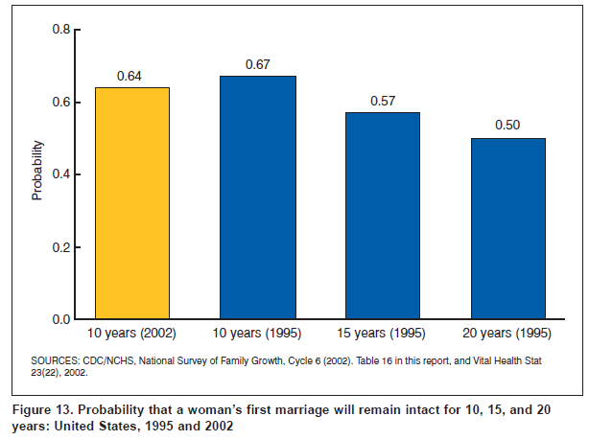

FIGURE 2

FIGURE 3

FIGURE 4
