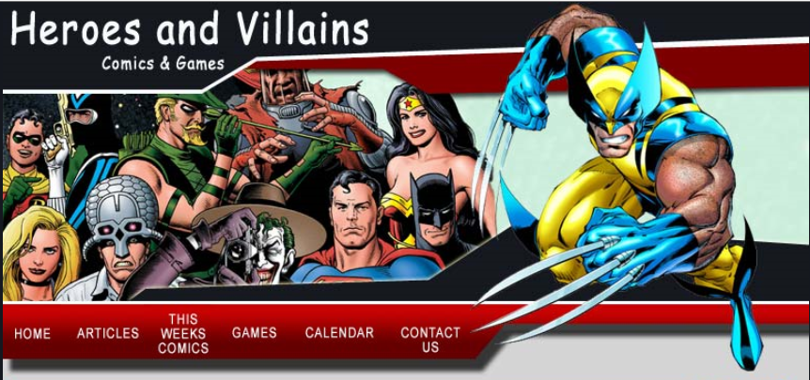
SuperHero vs Villain
You’ve been tasked to design a comic book database for new mobile app, that is going to organize and manage detailed information about your comic books like when you purchased the comic, how much it cost, what the condition of the comic is, and most importantly a rating and note system.

A mockup image of the app is provided to help you determine how to possibly organize some of the potential data that you’ll be collecting. (You do not have to capture everything!)
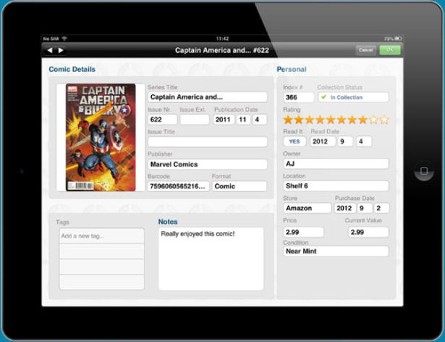
Now it’s up to you to design the database layout and table structure. You’ll be expected to use multiple joining tables making use of constraint and keys to maintain data integrity. You’ll be expected to utilize different data types to meet the requirements. You should expect to use Primary Keys as well as Foreign Keys. You’ll be expected to insert some relative data, and create a view based on a specific need. You’ll be expected to create a standard naming convention and follow it.
Create a one page document that steps through each creation/insert/update step by scripting to a new query window.
- Create a new comic database first to keep all comic tables organized and separate.
- Create your tables and joins, insert data, and create a view that pulls all the information together.
- Provide a snapshot of your database design diagram.
- Create (1) View
- Create (1) Query and print a snapshot of the execution plan.
A possible table layout for this requirement could look similar to the following:

