WebRegistrationApp v1.0.0
Database Design Document (DDD) v 1.0.0

Program Chair: Stephanie Cook

Prepared by:
Kimberly Garnto
State College of Florida

DATE: April 15, 2015

Coordination/Approval
Organization |  |  | Coordination | Date

SCHEMA CHANGES:
The following changes have been made to the schema since the last version of the database:
Schema Ver/ Change # | Change | Affected Pages

List of Document Versions
Version 1.0.0 April 15, 2015

Document Changes
The following changes have been made to this document:

Schema Ver/ Change# | Change | Affected Pages

Table of Contents
Chapter 1: Scope 5
1.1 Identification 5
1.2 Database Schema Overview 5
1.3 Referenced Documents 5
1.4 Document Overview 5
Chapter 2: Database-Wide Design Decisions 6
2.1 Database Platform and Description 6
2.3 Database Design Approach 7
Chapter 3: Detailed Design of the Database 8
3.1 [Schema Name] Database Objects 8
3.1.1.1 [First Table Name] 8
3.1.1.1.1 Structure 8
3.1.1.1.2 Indexes 8
3.1.1.1.3 Constraints 8
3.1.1.1.4 Foreign Keys 8
3.1.1.1.5 Sequences 8
3.1.1.1.6 Triggers 8
3.1.1.2 [Second Table Name] 8
3.1.1.2.1 Structure 8
3.1.1.2.2 Indexes 8
3.1.1.2.3 Constraints 8
3.1.1.2.4 Foreign Keys 9
3.1.1.2.5 Sequences 9
3.1.1.2.6 Triggers 9
3.1.2 Views 9
3.1.3 Stored Procedures 9
3.1.4 Stored Functions 9
Appendix A: Acronym List 10
Appendix B: Entity Relationship Diagram (+5 Points) 11

Chapter 1: Scope

1.1 Identification
This paragraph should identify the system and the software to which this document applies, including, as applicable, identification number(s), title(s), abbreviation(s), version number(s), and release number(s).

1.2 Database Schema Overview
The [schema name] [describe the purpose of the database and describe the general nature of the database; summarize the history of its development, use and maintenance; and identify the field user(s) of the application.]

1.3 Document Overview
This DDD will describe the overall database design including all database objects, database diagrams and maintenance plans.

Chapter 2: Database-Wide Design Decisions

2.1 Database Platform and Description
The Production, Test and Development databases exist on servers running SQL Server 2012. The [schema name] schema contains the actual [application name] data while the [schema name] schema contains information regarding report definitions.

2.2 Database Design Approach
[Describe the database design approach.]
Below are some of the key areas of the database design. Not every database element is mentioned in this section. Refer to chapter 3 for more details.
[Insert subparagraphs to list and briefly describe the key elements of the database, include information about users and the user setup to access the database
Create at least (2) different user accounts, and provide credentials for each account. Provide DML scripts to test the different access for each account. – (+5 points)
Include DML scripts here that would be used to test Triggers, Stored Procedures or Functions (+10 points)
]

Chapter 3: Detailed Design of the Database

WebRegistrationApp Database Objects
    - Tables
      - dbo.Buildings

The dbo.Buildings table maintains a listing of the different Buildings and Building_Ids for which classes can be held. Each unique building is associated with a campus.
        - Structure
Field | Type | Nullable | Description | Default
BldgCode_Id | INT | No | PK: Unique Numeric Identifier
BldgCode | NVARCHAR(4) | No | Building Code
BldgCode_Desc | NVARCHAR(50) | No | Building Description
BldgCode_Campus_Id | INT | No | FK: Campus_Id; REF: Campuses

        - Indexes

There are no indexes for this table.
        - Constraints
- Constraint Name | Type | Columns
UNQ_Building | Unique | BldgCode_Id

        - Foreign Keys
Foreign Key Constraint Name | Affected Field | Source Schema | Source Table
FK_Buildings_Campuses_on_Campus_Id | Campus_Id | WebRegistrationApp | Campuses

        - Triggers
There are no triggers for this table.
      - dbo.Campuses

The dbo.Campuses table maintains a listing of the different Campuses and Campus_Ids for which classes can be held.
        - Structure
Field | Type | Nullable | Description | Default
Campus_Id | INT | No | PK: Unique; FK REF: Buildings, Courses
Campus | NVARCHAR(30) | No | Campus Value
        - Indexes

There are no indexes for this table.
        - Constraints
There are no constraints for this table.
        - Foreign Keys
There are no Foreign Keys for this table.
        - Triggers
There are no Triggers for this table.
      - dbo.CourseMeetings

The dbo.CourseMeetings table maintains the information about Course Schedule Meeting Dates, Days of the Week the classes meet, and the times that the classes meets. The dbo.CourseMeetings table must join with the dbo.Courses table to get Course_Id and Course Details.
        - Structure
Field | Type | Nullable | Description | Default
CourseMeet_Id | INT | No | PK: Unique Numeric Identifier
CourseMeet_Course_Id | INT | No | FK
CourseMeet_TermCode | NVARCHAR(6) | No
CourseMeet_BldgCode_Id | INT | No
CourseMeet_RoomNumb | NVARCHAR(5) | No
CourseMeet_BeginDate | Date | Yes
CourseMeet_EndDate | Date | Yes
CourseMeet_Monday | BIT | Yes
CourseMeet_Tuesday | BIT | Yes
CourseMeet_Wednesday | BIT | Yes
CourseMeet_Thursday | BIT | Yes
CourseMeet_Friday | BIT | Yes
CourseMeet_BeginTime | Time | Yes
CourseMeet_EndTime | Time | Yes

        - Indexes
There are no indexes for this table.
        - Constraints
[Insert table constraints here.]
        - Foreign Keys
[Insert Table Foreign Keys here.]
        - Triggers
[Insert Table Triggers here with SQL Code if Trigger on Table.]
      - dbo.Courses

The dbo.Courses table maintains the detailed information about the Course, such as the Name of the Course, the course number, and the enrollment of the course.
        - Structure
Field | Type | Nullable | Description | Default
Course_Id | INT | No | PK: Unique Numeric Identifier
Course_SubjCode | NVARCHAR(4) | No
Course_CrseNumb | NVARCHAR(4) | No
Course_Title | NVARCHAR(50) | No
Course_Description | NVARCHAR(1000) | No
Course_SeatsAvail | NUMERIC(18,0) | No
Course_MaxEnrl | NUMERIC(18,0) | No
Course_Lec | BIT | Yes
Course_Lab | BIT | Yes
Course_Enrl | NUMERIC(18,0) | Yes
Course_CreditHrs | NUMERIC(18,0) | Yes
Course_Campus_Id | INT | No | FK:

        - Indexes
[Insert table indexes here.]
        - Constraints
[Insert table constraints here.]
        - Foreign Keys
Foreign Key Constraint Name | Affected Field | Source Schema | Source Table
FK_Courses_Campus_on_Campus_Id | Courses_Campus_Id | WebRegistrationApp | Campuses

        - Triggers
Trigger: tr_CourseEnrl
USE [WebRegistrationApp]
GO

/****** Object: Trigger [dbo].[tr_CourseEnrl] Script Date: 4/16/2015 5:36:34 PM ******/
SET ANSI_NULLS ON
GO

SET QUOTED_IDENTIFIER ON
GO

-- =============================================
-- Author: Garnto, Kimberly
-- Create date: April 15, 2015
-- Description: When inserting a new course with the max enrollment, go ahead -- and set the course_enrl
-- and the Course_SeatsAvail to the same value as the Course_MaxEnrol
-- =============================================
CREATE TRIGGER [dbo].[tr_CourseEnrl] ON [dbo].[Courses]
INSTEAD OF INSERT
AS
BEGIN
INSERT Courses (Course_SubjCode, Course_CrseNumb, Course_Title, Course_Description,
Course_SeatsAvail, Course_MaxEnrl, Course_Lec, Course_Lab, Course_Enrl,
Course_CreditHrs, Course_Campus_Id)
SELECT Course_SubjCode, Course_CrseNumb, Course_Title, Course_Description,
Course_MaxEnrl, Course_MaxEnrl, Course_Lec, Course_Lab, Course_MaxEnrl,
Course_CreditHrs, Course_Campus_Id
FROM inserted;

      - dbo.Faculty

The dbo.Faculty table maintains a listing of the different Faculty, with First Name, Last Name and Middle Initial Information. The Faculty_FullName column is a computed column.
        - Structure
Field | Type | Nullable | Description | Default
Faculty_Id | INT | No | PK: Unique Numeric Identifier
Faculty_FirstName | NVARCHAR(25) | No | Faculty First Name
Faculty_LastName | NVARCHAR(30) | No | Faculty Last Name
Faculty_MiddleInitial | NVARCHAR(1) | Yes | Faculty Middle Initial
Faculty_FullName |  |  | Computed Column

        - Indexes

There are no indexes for this table.
        - Constraints
- Constraint Name | Type | Columns
UNQ_Faculty_Id | Unique | Faculty_Id

        - Foreign Keys
There are no foreign keys for this table.
        - Triggers
There are no triggers for this table.

      - dbo.FacultyAssignments

The dbo.FacultyAssignments table is a joining table that links Faculty Information with Course Information so that you can have an association of the different types of data.
        - Structure
Field | Type | Nullable | Description | Default
FacultyAssign_Id | INT | No | PK: Unique Numeric Identifier
FacultyAssign_Faculty_id | INT | No | FK: REF dbo.Faculty
FacultyAssign_CourseId | INT | No | FK: REF dbo.Courses
FacultyAssign_PrimInd | BIT | Yes | Primary Instructor Indicator – Default ‘Y’
FacultyAssign_TermCode | NVARCHAR(6) | NO | Term Code

        - Indexes

There are no indexes for this table.
        - Constraints
- Constraint Name | Type | Columns
UNQ_FacultyAssign_Id | Unique | FacultyAssign_Id

        - Foreign Keys
There are no foreign keys for this table.
        - Triggers
There are no triggers for this table.

      - dbo.Registrations

The dbo.Registrations table is a joining table that maintains the classes that each student is taking for the term.
        - Structure
Field | Type | Nullable | Description | Default
Registration_Id | INT | No | PK: Unique Numeric Identifier
Student_Id | INT | No | FK: dbo.Students
Course_Id | INT | No | FK: dbo.Courses
Registration_TermCode | NVARCHAR(6) | Yes | Term Code Information

        - Indexes

There are no indexes for this table.
        - Constraints
- Constraint Name | Type | Columns
UNQ_Registration_Id | Unique | Registration_Id

        - Foreign Keys
There are no foreign keys for this table.
        - Triggers
There are no triggers for this table.

      - dbo.Students

The dbo.Students table maintains a listing of the different Students, with First Name, Last Name and Middle Initial Information. The Student_FullName column is a computed column.
        - Structure
Field | Type | Nullable | Description | Default
Student_Id | INT | No | PK: Unique Numeric Identifier
Student _FirstName | NVARCHAR(25) | No | Faculty First Name
Student _LastName | NVARCHAR(30) | No | Faculty Last Name
Student _MiddleInitial | NVARCHAR(1) | Yes | Faculty Middle Initial
Student _FullName |  |  | Computed Column

        - Indexes

There are no indexes for this table.
        - Constraints
- Constraint Name | Type | Columns
UNQ_ Student _Id | Unique | Student _Id

        - Foreign Keys
There are no foreign keys for this table.
        - Triggers
There are no triggers for this table.

    - Views

[List and describe all the views associated with the database. This should include the Structure, Dependencies, and Definition.]
    - Stored Procedures

[List and describe all the stored procedures associated with the database.]

    - Stored Functions

[List and describe all the stored functions associated with the database.]

Appendix A: Acronym List
Acronym | Definition
App | Application
Bldg | Building
Numb | Number

Appendix B: Entity Relationship Diagram (+5 Points)

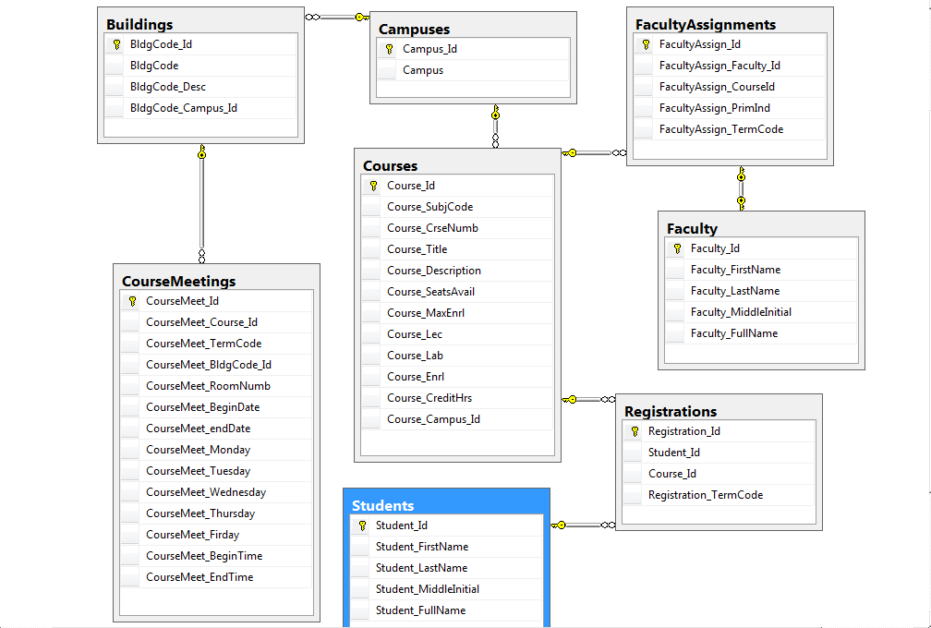

Appendix C: Maintenance Plan (+5 Points)

